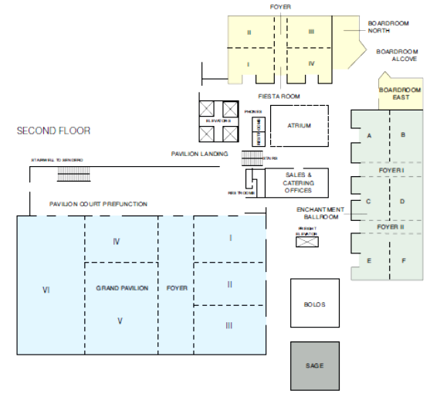
The Clyde Hotel
2nd Floor (meeting rooms, lunch)

